**Name: Saurav Jaiswal**

**UID: 18BCS1047**

**Section: 18K2G1**

**Subject/Subject-code: Design and Analysis of Algorithms Lab (CSP-309)**

**PRACTICE PROBLEMS**

**Question 1 –**

**0 - 1 Knapsack Problem**

**Link-** [**https://practice.geeksforgeeks.org/problems/0-1-knapsack-problem/0**](https://practice.geeksforgeeks.org/problems/0-1-knapsack-problem/0)

You are given weights and values of **N** items, put these items in a knapsack of capacity **W** to get the maximum total value in the knapsack. Note that we have only **one quantity of each item**.  
In other words, given two integer arrays **val[0..N-1]** and **wt[0..N-1]** which represent values and weights associated with **N** items respectively. Also given an integer W which represents knapsack capacity, find out the maximum value subset of **val[]** such that sum of the weights of this subset is smaller than or equal to **W.** You cannot break an item, **either pick the complete item, or don’t pick it (0-1 property)**.

**Input:**  
The first line of input contains an integer **T** denoting the number of test cases. Then **T** test cases follow. Each test case consists of four lines.  
The first line consists of **N** the number of items.  
The second line consists of **W**, the maximum capacity of the knapsack.  
In the next line are **N** space separated positive integers denoting the values of the **N** items,  
and in the fourth line are **N** space separated positive integers denoting the weights of the corresponding items.

**Output:**  
For each testcase, in a new line, print the **maximum possible** value you can get with the given conditions that you can obtain for each test case in a new line.

**Constraints:**  
1 ≤ T ≤ 100  
1 ≤ N ≤ 1000  
1 ≤ W ≤ 1000  
1 ≤ wt[i] ≤ 1000  
1 ≤ v[i] ≤ 1000

**Example:**  
**Input:**  
2  
3  
4  
1 2 3  
4 5 1  
3  
3  
1 2 3  
4 5 6  
**Output:**  
3  
0  
**Explanation:**  
**Test Case 1:**With W = 4, you can either choose the 0th item or the 2nd item. Thus, the maximum value you can generate is the max of val[0] and val[2], which is equal to 3.  
**Test Case 2:**With W = 3, there is no item you can choose from the given list as all the items have weight greater than W. Thus, the maximum value you can generate is 0.

**Solution:**

#include <bits/stdc++.h>

using namespace std;

int knapsack(int wt[],int val[],int s,int n){

int i,j,t[n+1][s+1];

for(i=0;i<=n;i++){

for(j=0;j<=s;j++){

if(i==0||j==0)

t[i][j]=0;

}

}

for(i=1;i<=n;i++){

for(j=1;j<=s;j++){

if(wt[i-1]<=j)

t[i][j]=max(val[i-1]+t[i-1][j-wt[i-1]],t[i-1][j]);

else

t[i][j]=t[i-1][j];

}

}

return t[n][s];

}

int main() {

/* Enter your code here. Read input from STDIN. Print output to STDOUT */

int t;

cin>>t;

while(t--){

int s,n,i;

cin>>n>>s;

int wt[n],val[n];

for(i=0;i<n;i++)

cin>>val[i];

for(i=0;i<n;i++)

cin>>wt[i];

cout<<knapsack(wt,val,s,n)<<"\n";

}

return 0;

}

**OUTPUT-**

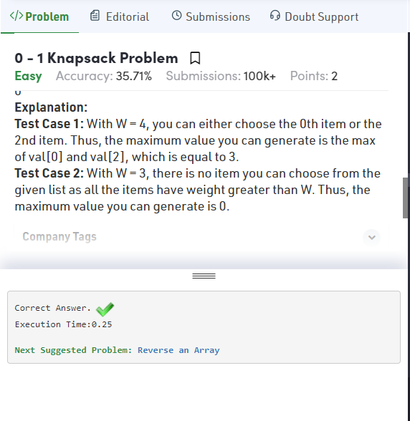

**Question 2 –**

**The Longest Common Subsequence**

**Link-** [**https://www.hackerrank.com/challenges/dynamic-programming-classics-the-longest-common-subsequence/problem**](https://www.hackerrank.com/challenges/dynamic-programming-classics-the-longest-common-subsequence/problem)

**Function Description**

Complete the *longestCommonSubsequence* function in the editor below. It should return an integer array of a longest common subsequence.

longestCommonSubsequence has the following parameter(s):

* *a*: an array of integers
* *b*: an array of integers

**Input Format**

The first line contains two space separated integers  and , the sizes of sequences  and .  
The next line contains  space-separated integers .  
The next line contains  space-separated integers .

**Output Format**

Print the longest common subsequence as a series of space-separated integers on one line. In case of multiple valid answers, print any one of them.

**Sample Input**

5 6

1 2 3 4 1

3 4 1 2 1 3

**Sample Output**

1 2 3

**Explanation**

There is no common subsequence with length larger than 3. And "1 2 3", "1 2 1", "3 4 1" are all correct answers.

**Solution:**

import java.io.*;

import java.math.*;

import java.security.*;

import java.text.*;

import java.util.*;

import java.util.concurrent.*;

import java.util.regex.*;

public class Solution {

// Complete the longestCommonSubsequence function below.

static int[] longestCommonSubsequence(int[] a, int[] b) {

int m,n,t[][],i,j;

m=a.length;

n=b.length;

t=new int[m+1][n+1];

//LCS matrix

for(i=0;i<=m;i++)

{

for(j=0;j<=n;j++)

{

if(i==0||j==0)

t[i][j]=0;

}

}

for(i=1;i<=m;i++)

{

for(j=1;j<=n;j++)

{

if(a[i-1]==b[j-1])

t[i][j]=1+t[i-1][j-1];

else

t[i][j]=Math.max(t[i][j-1],t[i-1][j]);

}

}

i=m;

j=n;

int len_lcs=t[m][n];

int lcs[]=new int[len_lcs];

len_lcs=len_lcs-1;

while(i>0&&j>0)

{

if(a[i-1]==b[j-1])

{

lcs[len_lcs--]=a[i-1];

i--;

j--;

}

else

{

if(t[i-1][j]>t[i][j-1])

i--;

else

j--;

}

}

return lcs;

}

private static final Scanner scanner = new Scanner(System.in);

public static void main(String[] args) throws IOException {

BufferedWriter bufferedWriter = new BufferedWriter(new FileWriter(System.getenv("OUTPUT_PATH")));

String[] nm = scanner.nextLine().split(" ");

int n = Integer.parseInt(nm[0]);

int m = Integer.parseInt(nm[1]);

int[] a = new int[n];

String[] aItems = scanner.nextLine().split(" ");

scanner.skip("(\r\n|[\n\r\u2028\u2029\u0085])?");

for (int i = 0; i < n; i++) {

int aItem = Integer.parseInt(aItems[i]);

a[i] = aItem;

}

int[] b = new int[m];

String[] bItems = scanner.nextLine().split(" ");

scanner.skip("(\r\n|[\n\r\u2028\u2029\u0085])?");

for (int i = 0; i < m; i++) {

int bItem = Integer.parseInt(bItems[i]);

b[i] = bItem;

}

int[] result = longestCommonSubsequence(a, b);

for (int i = 0; i < result.length; i++) {

bufferedWriter.write(String.valueOf(result[i]));

if (i != result.length - 1) {

bufferedWriter.write(" ");

}

}

bufferedWriter.newLine();

bufferedWriter.close();

scanner.close();

}

}

**OUTPUT-**

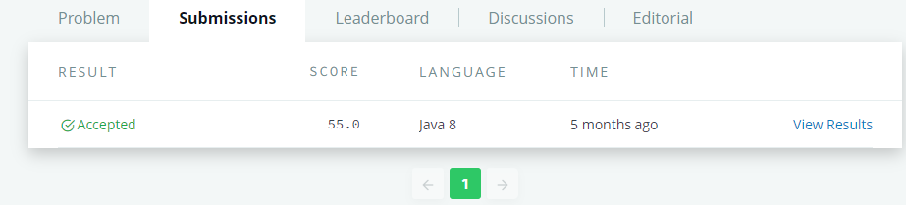

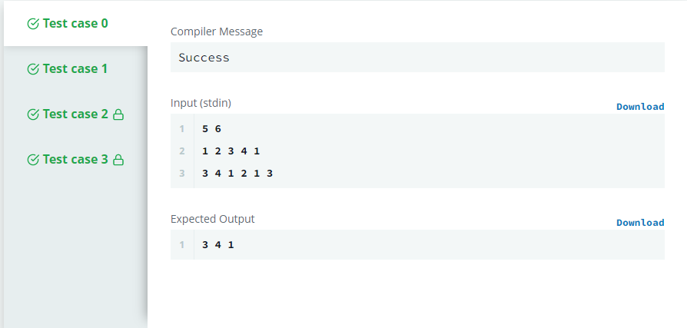

**Question 3 –**

**Knapsack**

**Link-** [**https://www.hackerearth.com/problem/algorithm/knapsack-1/description/**](https://www.hackerearth.com/problem/algorithm/knapsack-1/description/)

Problem Statement

Given a list of n integers, A={a1,a2,…,an}, and another integer, k representing the expected sum. Select zero or more numbers from A such that the sum of these numbers is as near as possible, but not exceeding, to the expected sum (k).

Note

Each element of A can be selected multiple times.

If no element is selected then the sum is 0.

Input Format

The first line contains T the number of test cases. Each test case comprises of two lines. First line contains two integers, n k, representing the length of list A and expected sum, respectively. Second line consists of n space separated integers, a1,a2,…,an, representing the elements of list A.

Constraints 1≤T≤10 1≤n≤2000 1≤k≤2000 1≤ai≤2000,where i∈[1,n]

Output Format

Output T lines, the answer for each test case.

**SAMPLE INPUT**

3

1 6

5

6 8

3 3 3 3 3 3

9 10

9 4 4 9 4 9 9 9 9

**SAMPLE OUTPUT**

5

6

9

**Solution:**

#include <bits/stdc++.h>

using namespace std;

int knapsack(int wt[],int s,int n){

int i,j,t[n+1][s+1];

for(i=0;i<=n;i++){

for(j=0;j<=s;j++){

if(i==0||j==0)

t[i][j]=0;

}

}

for(i=1;i<=n;i++){

for(j=1;j<=s;j++){

if(wt[i-1]<=j)

t[i][j]=max(wt[i-1]+t[i][j-wt[i-1]],t[i-1][j]);

else

t[i][j]=t[i-1][j];

}

}

return t[n][s];

}

int main() {

/* Enter your code here. Read input from STDIN. Print output to STDOUT */

int t;

cin>>t;

while(t--){

int s,n,i;

cin>>n>>s;

int wt[n];

for(i=0;i<n;i++)

cin>>wt[i];

cout<<knapsack(wt,s,n)<<"\n";

}

return 0;

}

**OUTPUT-**

